**Calculating Family Expenses Using Service Now**

|  |  |
| --- | --- |
| Date | 29 june 2025 |
| Team ID | LTVIP2025TMID28895 |
| Project Name | Calculating family expenses using service now |
| Maximum Marks | 4 Marks |

**Calculating Family Expenses Using Service Now:**

Brainstorming provides a free and open environment where family members or project team members can contribute ideas to improve and automate the tracking of family expenses. In this ServiceNow-based project, all ideas-big or small-are welcomed, focusing more on idea quantity than quality in the beginning. Out-of-the-box suggestions like integrating monthly budgeting, setting spending limits, automating alerts for due bills, or generating family expense reports are encouraged. Team members build on each other's ideas, resulting in multiple creative solutions.

Reference: <https://www.mural.co/templates/brainstorm-and-idea-prioritization>

**Step-1: Team Gathering, Collaboration and Select the Problem Statement**



**Step-2: Brainstorm, Idea Listing and Grouping**

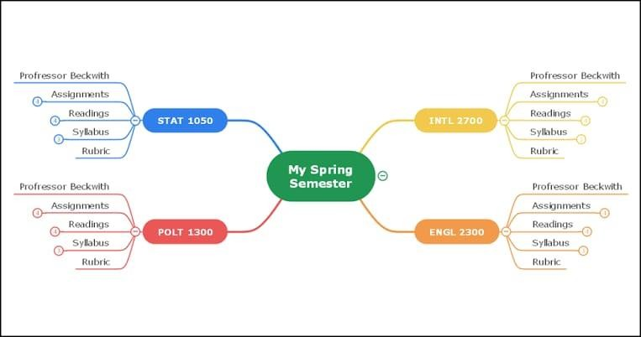

**Step-3: Idea Prioritization:**

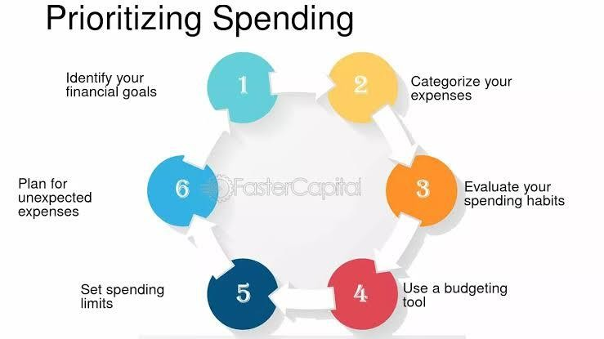

**Idea Prioritization:**

Idea Prioritization helps break down complex projects into clear, focused components. In this project, the main goal is to record and manage family expenses effectively using ServiceNow. This approach ensures accurate tracking of expenses, better budgeting, and improved financial planning. By prioritizing ideas, we can separate core expense tracking features from additional enhancements like reporting and exporting. It also highlights the importance of user-friendly interfaces and data accuracy. Each step, from expense entry to generating summaries, becomes easier to plan and implement. Clear visual representations like forms, lists, and reports can simplify communication. Overall, idea prioritization strengthens project clarity and supports smooth execution.